The operon of glyoxylate metabolism is part of the genomic island containing the ibeA gene, the product of which binds to the receptor present on the endothelial cells of the brain.

This island is described in the meningitis-causing strain *Escherichia coli K1*, and by experimental mutagenesis has been shown to be functionally significant for the manifestation of the pathogenic properties [Huang, 2001]. The island contains four operons: the ibe operon associated with invasion, as well as three operons of the metabolism of hydrocarbons and glycerol (ptn, cgl, gcx) [Rakitina, 2017].

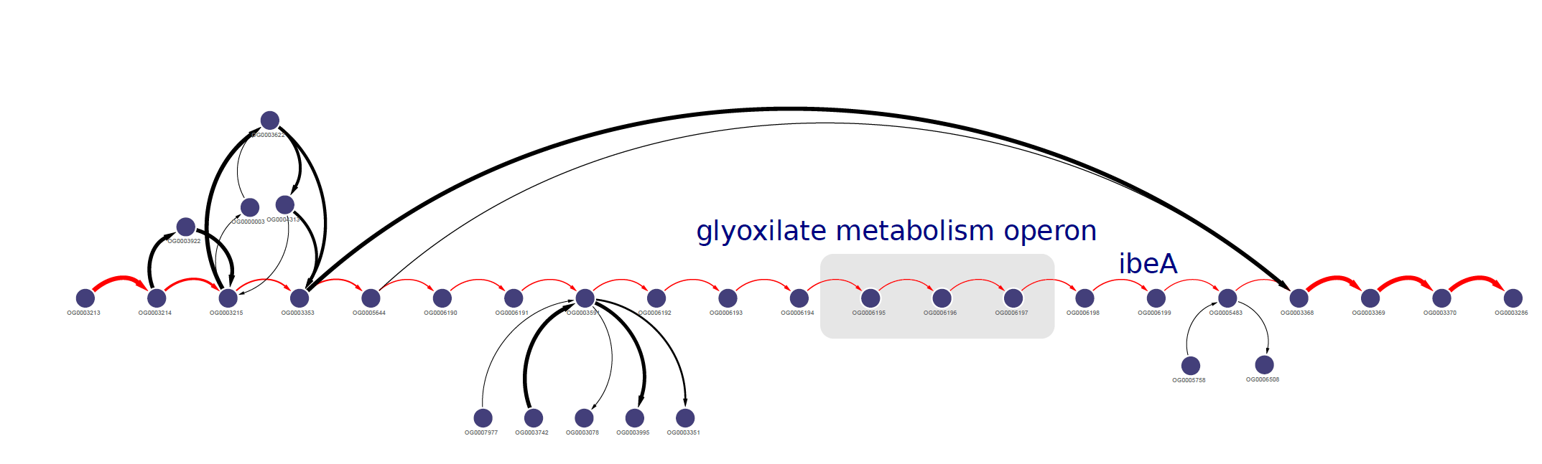

**Literature**

Huang, S. H., Chen, Y. H., Kong, G., Chen, S. H., Besemer, J., Borodovsky, M., & Jong, A. (2001). A novel genetic island of meningitic Escherichia coli K1 containing the ibeA invasion gene (GimA): functional annotation and carbon-source-regulated invasion of human brain microvascular endothelial cells. *Functional & integrative genomics*, *1*(5), 312-322.

Rakitina, D. V., Manolov, A. I., Kanygina, A. V., Garushyants, S. K., Baikova, J. P., Alexeev, D. G., ... & Karpova, I. Y. (2017). Genome analysis of E. coli isolated from Crohn’s disease patients. *BMC genomics*, *18*(1), 544.